B. Tech Degree VI Semester Examination April 2016
ME 1605 CAD/CAM (2006 Scheme)
Answer Key & Scheme
Part A Marks
a | - Subjugation of human being by machine  - Reduction in labour requirement  - Reduction in purchasing power as unemployment rises  - Offloading of jobs | 5
b | A wire-frame model uses interconnecting lines (straight line segments) to depict the object. Wire-frame models of complicated geometries can become somewhat confusing because all of the lines depicting the shape of the object are usually shown, even the lines representing the other side of the object. These so-called hidden lines can be removed, but even with this improvement, wire-frame representation is still often confusing. It is rarely used today.  In solid modeling an object is modeled in solid three dimensions, providing the user with a vision of the object that is similar to the way it would be seen in real life. More important for engineering purposes, the geometric model is stored in the CAD system as a 3-D solid model, providing a more accurate representation of the object. This is useful for calculating mass properties, in assembly to perform interference checking between mating components, and in other engineering calculations. | 5
c | G codes are preparatory function codes which decides the mode of operation of the CNC machine like movement of slides (rapid-G00, linear interpolation -G01, circular interpolation-G01), absolute or incremental (G90 and G91), units (G70, G71), specification of feed (mm/min-G94, mm/rev-G95) etc. M codes are Machine function codes like machine stop (M00, M01, M30), spindle rotation (M03,M04), tool change (M06), coolant on/off (M07/M09) etc. | 5
d | A canned cycle is a way of conveniently performing repetitive CNC machine operations. Canned cycles automate certain machining functions such as drilling, boring, tapping, pocketing, etc. Example: G81 performs 1) positioning in XY plane 2) positioning in Z direction 3) spindle on, 4) movement to the required depth with specified feed, 5) spindle stop and 6) tool retraction. | 5
e | ATC is the acronym for Automatic Tool Changer. ATCs are used to reduce the tool changing time in Turning Centres and Machining Centres. ATCs enable CNC machines to combine different operations as all the required tools can be initially loaded in to the machine. In Turning Centres turrets are used for automatic tool changing. In Machining Centres Tool Magazines are used for holding the tool. Machining Centres also use a tool changing arm for transferring tools from the magazine to the spindle.  APC is the acronym for Automatic Pallet Changer. APC is used to reduce the setup time and hence to increase the utilization of Machining Centres. APC a changeable machine table. While the machine is working on one table, jobs can be loaded on other tables. Once the machining operation on the current table is over, it can be removed and a new table with job loaded on it can be brought to the working position. APCs add flexibility to the machining centre. | 5
f | Static errors are geometric and dimensional errors when the machine is not running. Static errors include positioning errors, repeatability, form errors like guideway straightness, spindle run-out (circularity error) etc. Dynamic errors are the errors induced while the machine is running. These can be caused by the acceleration and deceleration of the slides, cutting load and vibration of the machine. Machine test chart give a clear indication of the static errors whereas on line techniques are used to determine dynamic errors. | 5
g | Computer Integrated Manufacturing (CIM) encompasses the entire range of product  development and manufacturing activities with all the functions being carried out with  the help of dedicated software packages. The data required for various functions are passed from one application software to another in a seamless manner. For example, the product data is created during design. This data has to be transferred from the modeling software to manufacturing software without any loss of data. CIM uses a common database wherever feasible and communication technologies to integrate design, manufacturing and associated business functions that combine the automated segments of a factory or a manufacturing facility. CIM reduces the human component of manufacturing and thereby relieves the process of its slow, expensive and error-prone component. CIM stands for a holistic and methodological approach to the activities of the manufacturing enterprise in order to achieve vast improvement in its performance. | 5
h | Accuracy – designates how close a measured value is to the true quantity of what is being measured.  Resolution – is the smallest increment the system can display or measure. A system can have a high resolution with poor repeatability and accuracy.  Repeatability (precision) – describes how well a system or device can reproduce an outcome in unchanged conditions.  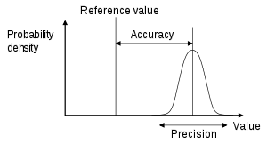 | 5
Part B
II | Detroit automation  Detroit type automation utilizes fixed automation methods like automated flow lines and transfer lines. Detroit type automation if for mass production of parts and assembled products like automobiles. In automated flow lines work stations are integrated mechanically with transfer mechanisms for work part transport from station to station. Flow lines have circular or inline configuration. Work part transfer methods include continuous, synchronous and asynchronous methods.  Transfer Machines  Transfer machines are combinations of individual machines or machine heads arranged in required sequence, connected by work part transfer mechanisms and integrated with interlocking controls. Transfer machines permit maximum number of operations to be performed on work pieces at a maximum production rate. Work part transfer methods include continuous, synchronous and asynchronous methods. These methods employ different work part transfer mechanisms. A transfer mechanism is the mechanism employed to transfer work parts/assemblies from one work station to another.  The commonly used mechanisms are:  1) conveyor belt  2) walking beam  3) Geneva mechanism  Line Balancing involves selecting the appropriate combination/grouping of work tasks to be performed at each workstation so that the work is completed in a feasible sequence (i.e., making standardized products sequentially step-by-step along the line of flow) within an acceptable cycle time and that the work is evenly divided among the workstations/workers (i.e., each workstation has approximately the same amount of work). Assembly Line balancing (ALB) is an attractive means for optimal balancing of the assembly lines/flow lines in Mass production and Continuous / repetitive production systems (Large-scale Serial production system). | 5  5  5
III | - General steps in Finite Element Method are classified as  - Pre-processing: Modelling, material specification, meshing, specifying boundary conditions and loading  - Solution: solution involves 1) calculation of element matrices, 2) assembly, 3) calculation of element load vectors and their assembly, 4) application of boundary conditions and 5) solution (linear, non-linear, transient etc.)  - Post processing: To present the results (primary and derived variables) in the form of charts, tables, surface and contour maps etc.  (Elaborate the points)  - Automated drafting  In traditional design process ideas and concepts were converted first into sketches and finally to component drawings, assembly drawings and part lists after a long process of analysis and evaluation. These were then given as inputs to material procurement, planning and manufacturing. Modern design process consists of geometric modelling, engineering analysis, design review and analysis and automated drawing. Geometric models are used for all the downstream process including, analysis, evaluation, engineering planning, manufacturing etc. However, 2D drawings in printed form are needed for record keeping, meeting mandatory requirements and for presentation purposes. Most of the CAD packages have automated drafting facility. 3D models are converted into fully dimensioned detailed drawings as per the company standards using the appropriate functions in the CAD package. This process is called automated drafting. | 10  5
IV | The APT language consists of four types of statements;  - Geometry statements are used to define the geometry for machining.  Examples:  P0 = POINT/1.0, 1.2, 1.3 (specifies a point at XYZ coordinates 1.0, 1.2, and 1.3, respectively)  L1 = LINE/P0, P1 (specifies a line by two points, previously defined)  C0 = CIRCLE/CENTER, P0, RADIUS, 1.0 0 (circle of radius 1 and centre at P0)  - Motion statements are used to specify the path taken by the tool.  FROM/P0 or FROM/ 0.0, 1.0, 2.0  GO/TO, L1, TO, PL1, TO, L2 (specifying that the tool should use line L1 as the drive surface, plane P1 as the part surface, and line L2 as the check surface.)  - Post-processor statements control the machinery, controlling coolants as well as the feeds and speeds.  SPINDL/600 (specifies the spindle to be 600 rpm.)  FEDRAT/6.0 (specifies a feed rate of 6 inches per minute.)  - Auxiliary statements complete the picture, specifying the part, required tools, etc.  CUTTER/0.25 (specifies a quarter-inch cutter diameter.) | 15
V | a) Open Loop b) closed loop  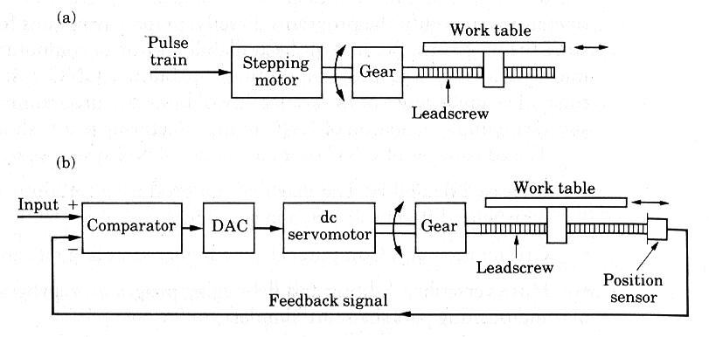  b) Linear and rotary transducers  A linear encoder is a sensor, transducer or reading-head linked to a scale that encodes position. The sensor reads the scale and converts position into an analog or digital signal that is transformed into a digital readout. Movement is determined from changes in position with time. Both optical and magnetic linear encoder types function using this type of method. However, it is their physical properties which make them different. (Marks can be awarded if any one type is explained with figure)  Working Principle (optical linear encoder)  The light source and lens produce a parallel beam of light which pass through four windows of the scanning reticule. The four scanning windows are shifted 90 degrees apart. The light then passes through the glass scale and is detected by photo sensors. The scale then transforms the detected light beam when the scanning unit moves. The detection of the light by the photo sensor produces sinusoidal wave outputs. The linear encoder system then combines the shifted signals to create two sinusoidal outputs which are symmetrical but 90 degrees out of phase from each other. A reference signal is created when a fifth pattern on the scanning reticule becomes aligned with an identical pattern on the scale.  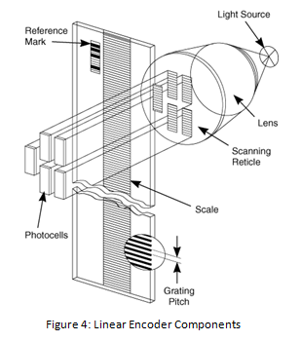  Rotary Encoder  Rotary encoders utilize sensors that use optical, mechanical or magnetic index counting for angular measurement. There are incremental and absolute type of encoders. (Marks can be awarded if any one type is explained with figure)  Working Principle (Incremental Optical rotary encoder)  Incremental rotary encoders utilize a transparent disk which contains opaque sections that are equally spaced to determine movement. A light emitting diode is used to pass through the glass disk and is detected by a photo detector. This causes the encoder to generate a train of equally spaced pulses as it rotates. The output of incremental rotary encoders is measured in pulses per revolution which is used to keep track of position or determine speed.  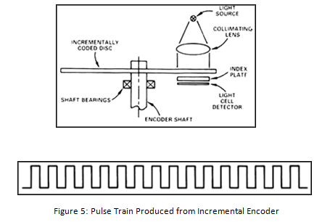 | 7  8
VI | a) Advantages of Ball Screws:  Ball screws convert rotary input to linear motion and offer several advantages over other actuators, such as Acme screws or other types of lead screws. Ball screws are more than 90% efficient whereas ordinary lead screws are less than 30% efficient. Ball screws work much quietly than the conventional lead screws. They can work at higher speeds and cause no back lash. They are much more expensive than conventional lead screws. Repair and maintenance of ball screws are costlier than lead screws. Depending upon their lead angle, ball screws can be back-driven due to their low internal friction (i.e., the screw shaft can be driven linearly to rotate the ball nut). They are usually undesirable for hand-fed machine tools, as the stiffness of a servo motor is required to keep the cutter from grabbing the work and self-feeding, that is, where the cutter and work piece exceed the optimum feed rate and effectively jam or crash together, ruining the cutter and work piece.  b) Swarf removal in CNC machines  Swarf, also known as chips or by other process-specific names (such as turnings, filings, or shavings), is pieces of metal, wood, or plastic that are the debris or waste resulting from machining, woodworking, or similar subtractive (material-removing) manufacturing processes  Swarf removal in CNC machines is accomplished by using chip conveyors. Chip conveyors are positioned below the cutting area. The swarf including chip and coolant falls on the conveyor belt which carries them to a chip tray. Coolant is filtered out are recirculated.  There are conveyor systems for handling all types and volumes of metal chips including steel, cast iron, aluminum, brass, copper, titanium, nickel and composites. Chip conveyors are sized based on material type, chip type and volume, coolant type (water soluble, semi-synthetic, synthetic, oil) and coolant flow rate. | 10  5
VII | Various testing and inspection methods for CNC machine tools  - Accuracy and repeatability (precision)  Positioning accuracy and repeatability of CNC machines are tested by using Laser Interferometers. The values of positioning and repeatability errors are specified by national and international standards. The reading obtained are compared to the standard values.  - Testing of Geometrical Accuracy  Geometrical accuracies like the straightness of the slides, squareness of the axes and run-out of the spindles are tested by using dial indicators, autocollimators etc.  - Cutting Performance  These tests are devised to 1) determine the process capability of the machines and 2) to test the maximum material removal rate (like maximum, depth of cut, speed, feed, and drill size etc.)  - Checking the specification  Test the machines for spindle power, maximum traverse, traverse speed and other specifications as per the order.  - Dynamics tests like vibration, acceleration deceleration, temperature rise, noise etc.  These tests are conducted to ascertain whether the noise, vibration and the temperature rise are within the acceptable level. | 15
VIII | - SCARA robot  The SCARA acronym stands for Selective Compliance Assembly Robot Arm or Selective Compliance Articulated Robot Arm. Its arm is rigid in the Z-axis and pliable in the XY-axes, which allowed it to adapt to holes in the XY-axes. By virtue of the SCARA's parallel-axis joint layout, the arm is slightly compliant in the X-Y direction but rigid in the ‘Z’ direction, hence the term: Selective Compliant. This is advantageous for many types of assembly operations, i.e., inserting a round pin in a round hole without binding. The second attribute of the SCARA is the jointed two-link arm layout similar to our human arms, hence the often-used term, Articulated. This feature allows the arm to extend into confined areas and then retract or “fold up” out of the way. This is advantageous for transferring parts from one cell to another or for loading/ unloading process stations that are enclosed  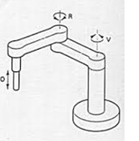  ii) Cylindrical robot  A cylindrical robotic system has three axes of motion – the circular motion axis and the two linear axes in the horizontal and vertical movement of the arm.  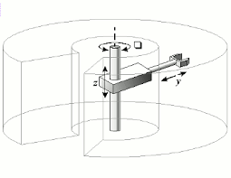  iii) Gantry robot  A gantry robot consists of a manipulator mounted onto an overhead system that allows movement across a horizontal plane. Gantry robots are also called Cartesian or linear robots. They are usually large systems that perform pick and place applications, but they can also be used in welding and other applications.  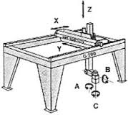 | 5  5  5  5
IX | - Direct Numerical Control  Direct numerical control (DNC), also known as distributed numerical control (also DNC), is a common manufacturing term for networking CNC machine tools. On some CNC machine controllers, the available memory is too small to contain the machining program (for example machining complex surfaces), so in this case the program is stored in a separate computer and sent directly to the machine, one block at a time. If the computer is connected to a number of machines it can distribute programs to different machines as required. Usually, the manufacturer of the control provides suitable DNC software. However, if this provision is not possible, some software companies provide DNC applications that fulfil the purpose. DNC networking or DNC communication is always required when CAM programs are to run on some CNC machine control.  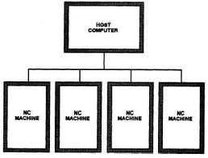  ii) FMS  A flexible manufacturing system (FMS) is a group of numerically-controlled machine tools, interconnected by a central control system. The various machining cells are interconnected, via loading and unloading stations, by an automated transport system. Operational flexibility is enhanced by the ability to execute all manufacturing tasks on numerous product designs in small quantities and with faster delivery. It has been described as an automated job shop and as a miniature automated factory. Simply stated, it is an automated production system that produces one or more families of parts in a flexible manner. Today, this prospect of automation and flexibility presents the possibility of producing nonstandard parts to create a competitive advantage.  iii) AI and Expert system  In artificial intelligence, an expert system is a computer system that emulates the decision-making ability of a human expert. Expert systems are designed to solve complex problems by reasoning about knowledge, represented primarily as if–then rules rather than through conventional procedural code.  The field of artificial intelligence (AI) is concerned with methods of developing systems that display aspects of intelligent behaviour. These systems are designed to imitate the human capabilities of thinking and sensing.  Characteristics of AI systems include:  1. Symbolic Processing  In AI applications, computers process symbols rather than numbers or letters. AI applications process strings of characters that represent real-world entities or concepts. Symbols can be arranged in structures such as lists, hierarchies, or networks. These structures show how symbols relate to each other.  2. Non-algorithmic Processing  Computer programs outside the AI domain are programmed algorithms; that is, fully specified step-by-step procedures that define a solution to the problem. The actions of a knowledge-based AI system depend to a far greater degree on the situation where it is used.  The Field of AI  Artificial intelligence is a science and technology based on disciplines such as computer science, biology, psychology, linguistics, mathematics, and engineering. The goal of AI is to develop computers that can think, see, hear, walk, talk and feel. A major thrust of AI is the development of computer functions normally associated with human intelligence, such as reasoning, learning, and problem solving.  An expert system (ES) is a knowledge-based system that employs knowledge about its application domain and uses an inferencing (reason) procedure to solve problems that would otherwise require human competence or expertise. The power of expert systems stems primarily from the specific knowledge about a narrow domain stored in the expert system's knowledge base. Expert systems do not have human capabilities. They use a knowledge base of a particular domain and bring that knowledge to bear on the facts of the particular situation at hand. The knowledge base of an ES also contains heuristic knowledge - rules of thumb used by human experts who work in the domain. | 5  5  5

